
EXPERIMENT 1
Analysis, Development and Verification of 8-bit and 16-bit Arithmetic Operations Using Assembly Language Program

OBJECTIVES:
- To develop and verify 8-bit Addition and Subtraction.
- To develop and verify 16-bit Addition and Subtraction.
- To develop and verify 8-bit Multiplication and Division.
- To develop and verify 16-bit Multiplication and Division.

COMPONENTS REQUIRED:
8085 microprocessor and 8085 simulator.

PROCEDURE:
- Enter the program into the 8085 microprocessor kit or simulator.
- Store the two 16-bit numbers or 8-bit in the specified registers or memory locations.
- Execute the program to perform addition, subtraction,Multiplication and division.
- Verify the result stored in the registers or memory locations.

- 8-bit Addition and Subtraction.
- PROGRAM:(ADDITION)

MVI C 00h
LDA 4201h
MOV B A
LDA 4200h
ADD B
JNC SKIP
CMA
INR A
INR C
SKIP: STA 4202h
MOV A C
STA 4203h
HLT

MEMORY AND DATA:

MEMORY | DATA
4200 | 4A
4201 | 2B
4202 | 75

RESULT:

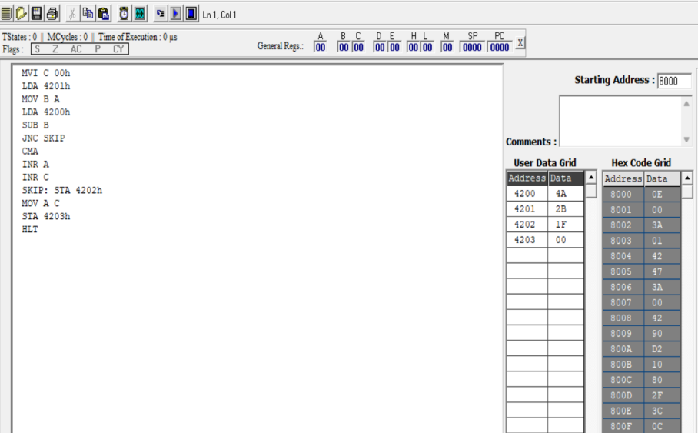

- PROGRAM:(SUBRACTION)

MVI C 00h
LDA 4201h
MOV B A
LDA 4200h
SUB B
JNC SKIP
CMA
INR A
INR C
SKIP: STA 4202
MOV A C
STA 4203h
HLT

MEMORY AND DATA:

MEMORY | DATA
4200 | 4A
4201 | 2B
4202 | 1F

RESULT:
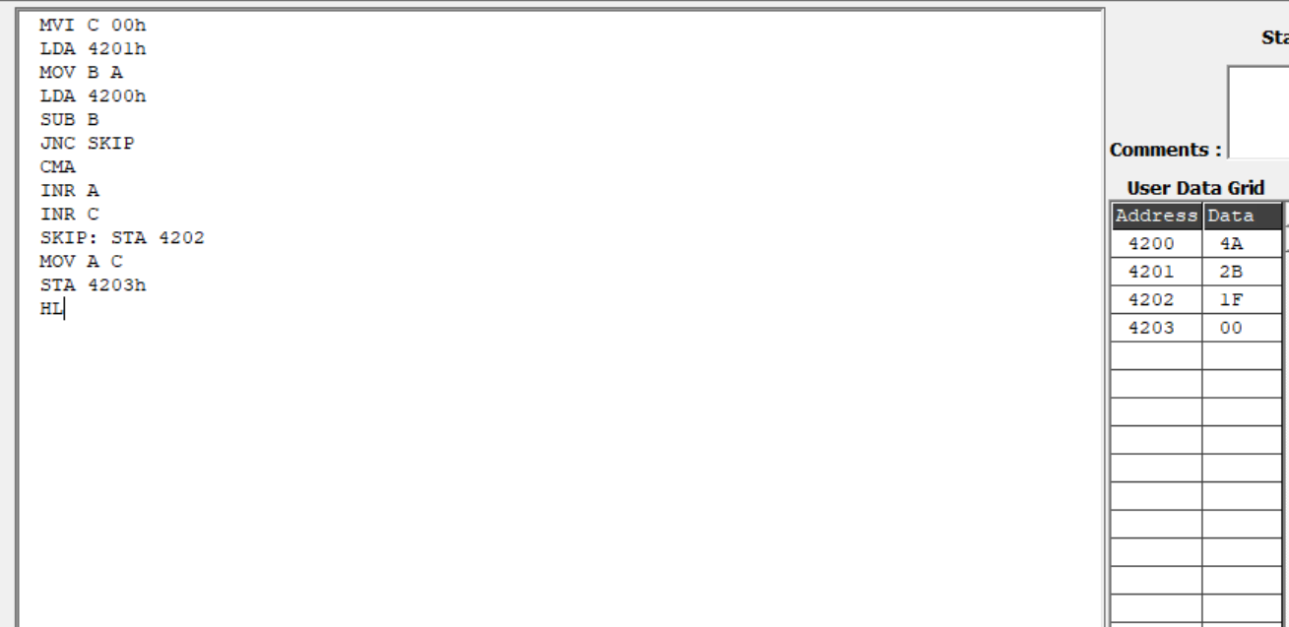

2.16-bit Addition and Subtraction.

- PROGRAM:(ADDITION)

LDA 4200
MOV B,A
LDA 4201
SUB B
STA 4202
HLT

MEMORY AND DATA:

MEMORY | DATA
4510 | 12
4511 | 34
4512 | 56
4513 | 78
4514 | 68
4515 | AC
4516 | 00

RESULT:
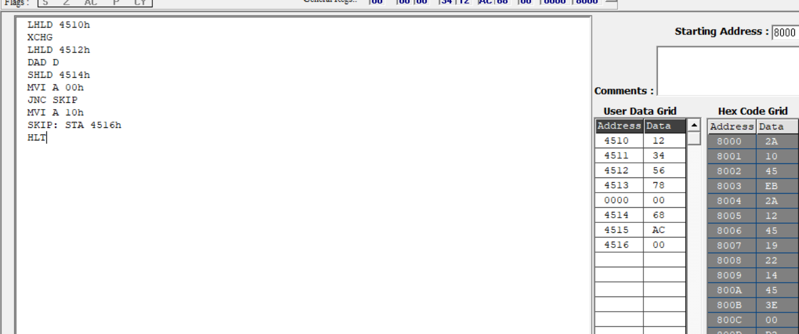

- PROGRAM:(SUBTRACTION)

LDA 4501h
MOV C A
LDA 4511h
MOV B A
LDA 4512h
SUB C
STA 4516h
LDA 4513h
SBB B
STA 4517h
MVI A 00h
SKIP: STA 4518
HLT

MEMORY AND DATA:

MEMORY | DATA
4510 | 12
4511 | 34
4512 | 56
4513 | 78
4516 | 44
4517 | 44
4518 | 00

RESULT
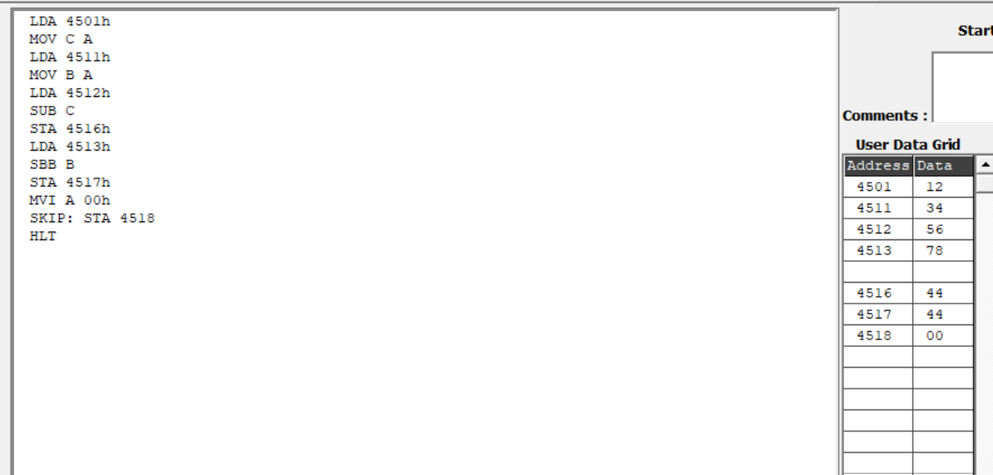
3.8-bit Multiplication and Division.

- PROGRAM:(MULTIPLICATION)

LDA 4201h
MOV E A
LDA 4202h
MOV C A
REPEAT: DAD D
DCR C
JNZ REPEAT
SHLD 4203h
HLT

MEMORY AND DATA:

MEMORY | DATA
4200 | 03
4201 | 08
4202 | 18

RESULT:

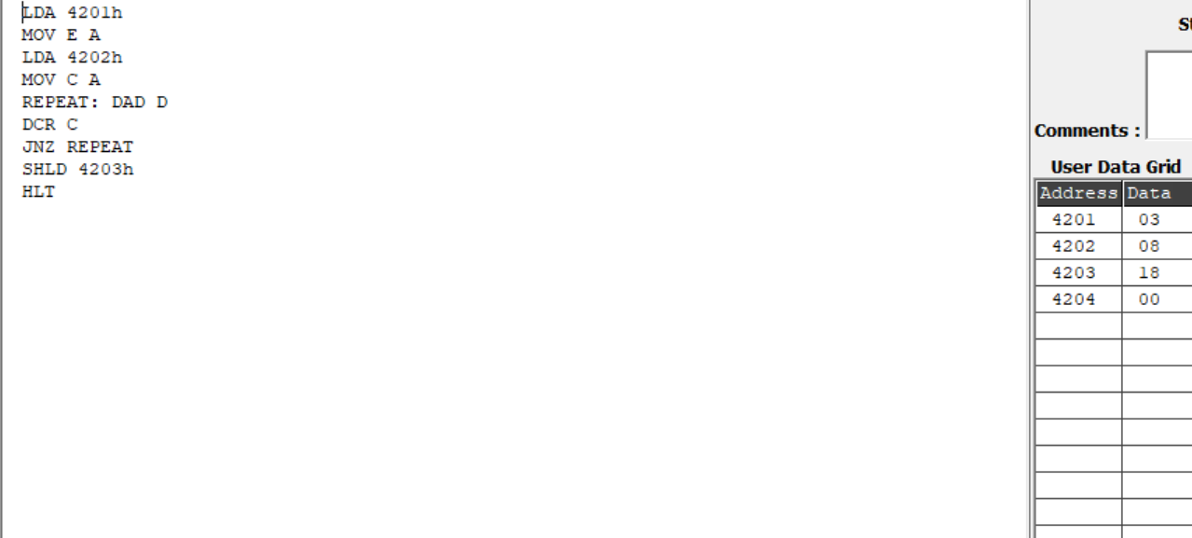

- PROGRAM:(DIVISION)

LDA 4201h
MOV B A
LDA 4200h
MVI C 00h
AGAIN: CMP B
JC STORE
SUB B
INR C
JMP AGAIN
STORE: STA 4203h
MOV A C
STA 4202h
HLT

MEMORY AND DATA:

MEMORY | DATA
4200 | F4
4201 | 2A
4202 | 05
4203 | 22

RESULT:
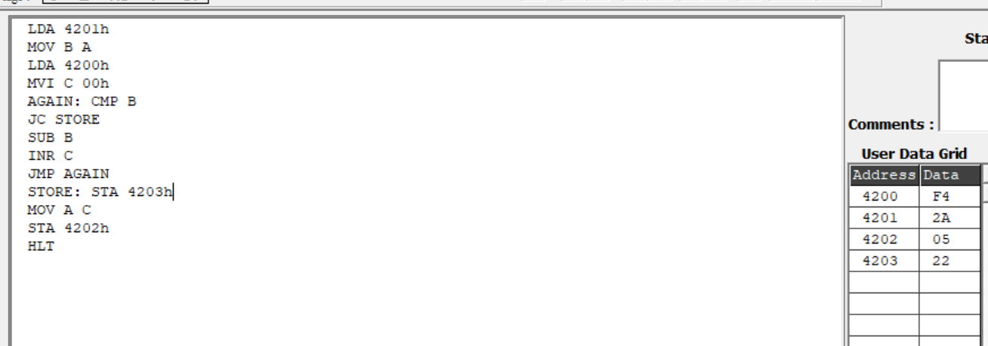

4.16-bit Multiplication and Division.
- PROGRAM:(MULTIPLICATION)

LHLD 4510
XCHG
LHLD 4512
MOV B H
MOV C L
LXI H 0000h
MVI A 00h
STA 4516
STA 4517
MOV A B
ORA C
JZ DONE
LOOP: DAD D
JNC NEXT
SHLD 4514
LHLD 4516
INX H
SHLD 4516
LHLD 4514
NEXT: DCX B
MOV A B
ORA C
JNZ LOOP
DONE: SHLD 4514
HLT

MEMORY AND DATA:

MEMORY | DATA
4510 | 34
4511 | 10
4512 | 12
4513 | 00
4514 | A8
4515 | 23
4516 | 01
4517 | 00

RESULT:
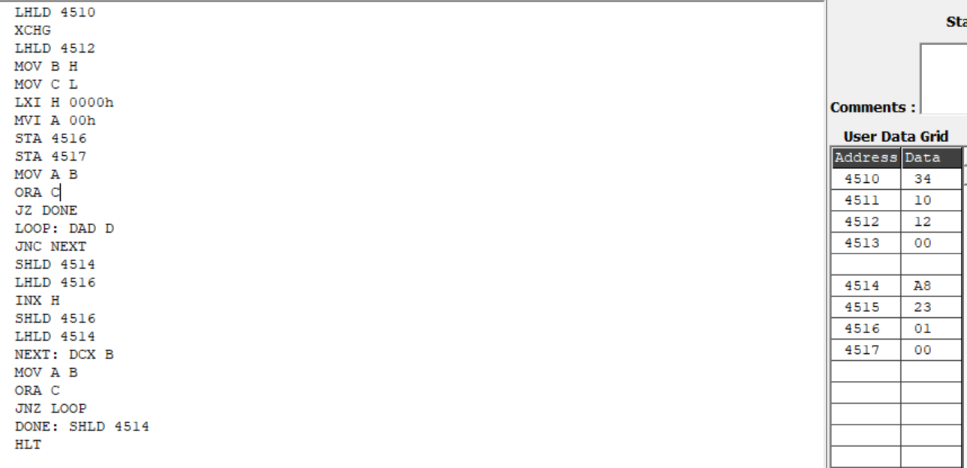

- PROGRAM:(DIVISION)

LHLD 4510
XCHG
LHLD 4512
LXI B 0000h

LOOP: MOV A H
CMP D
JC DONE
JNZ SUBTRACT
MOV A L
CMP E
JC DONE

SUBTRACT: MOV A L
SUB E
MOV L A
MOV A H
SBB D
MOV H A
INX B
JMP LOOP

DONE: SHLD 4514
MOV H B
MOV L C
SHLD 4516
HLT

MEMORY AND DATA:

MEMORY | DATA
4510 | 10
4511 | 00
4512 | 34
4513 | 12
4514 | 04
4515 | 00
4516 | 23
4517 | 01

RESULT
